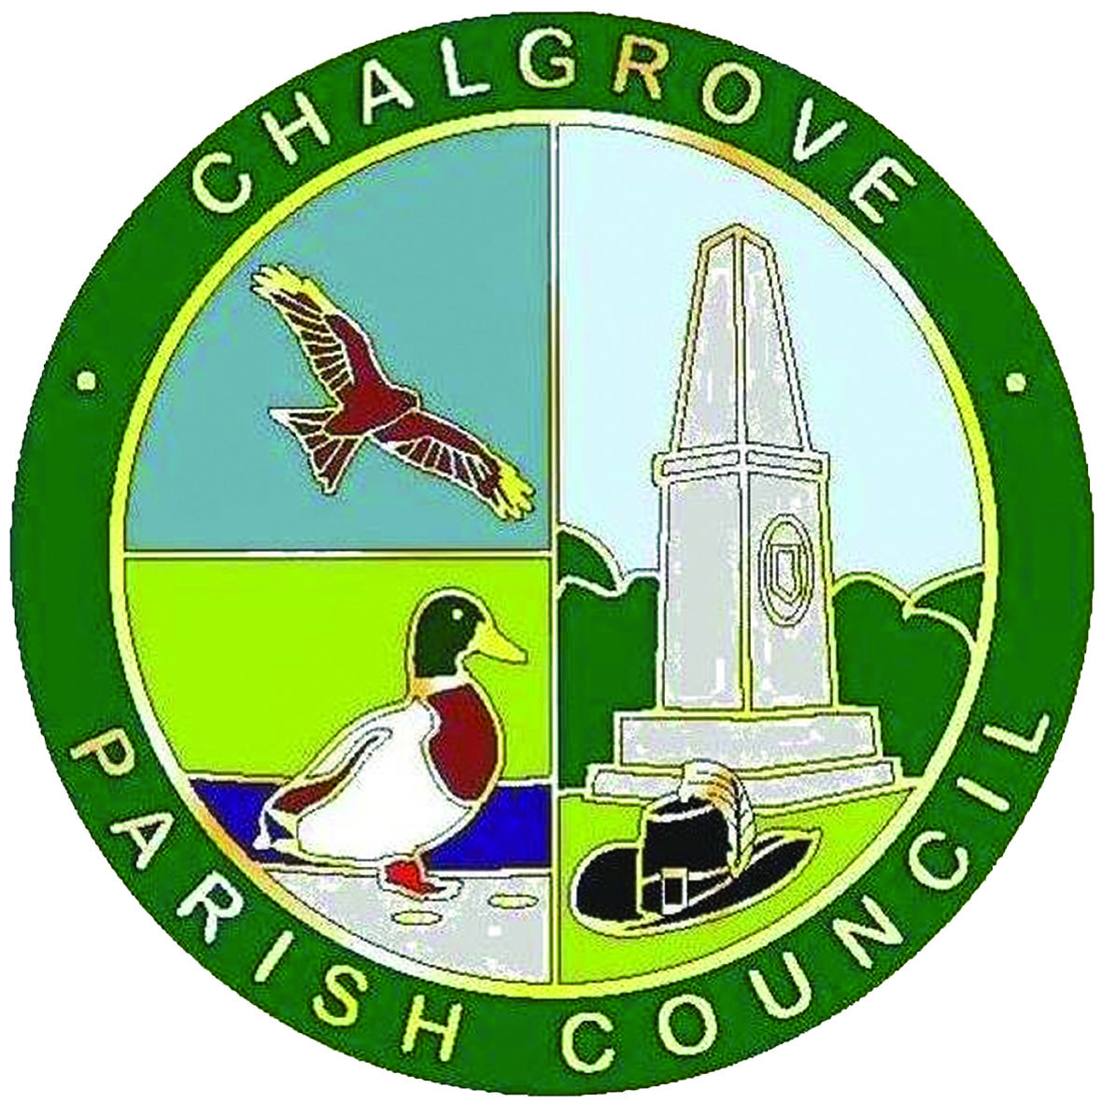
Chalgrove Parish Council
_____________________________________________
FACILITIES BOOKING FORM

Facility Required | Chalgrove Village Hall

Date Required | Hire Start Time | Hire Finish Time | Resident | Non-Resident

Name of Applicant
Organisation (if applicable)
Address
Telephone Number(s)
Email Address

Type of Function
Approx. Number of Attendees

Are you applying for a TENS license YES / NO
A TENS license permits the sale of alcohol and can be applied for on the South Oxfordshire District Council website.
Do you require the stage at a cost of £50: YES / NO
Hire Cost
Total Hours
Extras (stage etc)
Total Hire Cost

Checklist Please ✓ those that apply
I have enclosed a deposit of £50 in either cash or cheque?
I have enclosed full payment in either cash or cheque?
I have paid a deposit of £50 by bank transfer?
I have paid full payment by bank transfer?
I have enclosed a £100 damages cheque?

If you are unable to provide a £100 damages cheque, the signing of this booking form constitutes your agreement that you will be invoiced for any damages resulting from your hire.

I DECLARE THAT I HAVE READ AND ACCEPTED THE TERMS & CONDITIONS OF HIRE
Print Name | Signature | Date

All correspondence to: The Parish Clerk – Jo Murphy, Chalgrove Parish Council
c/o 13 Laurel Close, Chalgrove. Oxfordshire. OX44 7RE
tel: 01865 890432 email: clerk@chalgrove.org web: www.chalgrove.org

